Proposal

Camera
- 60-100 fps
- Firewire
- NI compatible
- Casing against outdoor lighting
- Self powered or by BusCard
- Tripod mount

New frame for secondary target

IEEE 1394 DV CardBus

Laser
- 2-3 lasers
- 6-9 battery

Batteries for the transmitter

DAQ Card

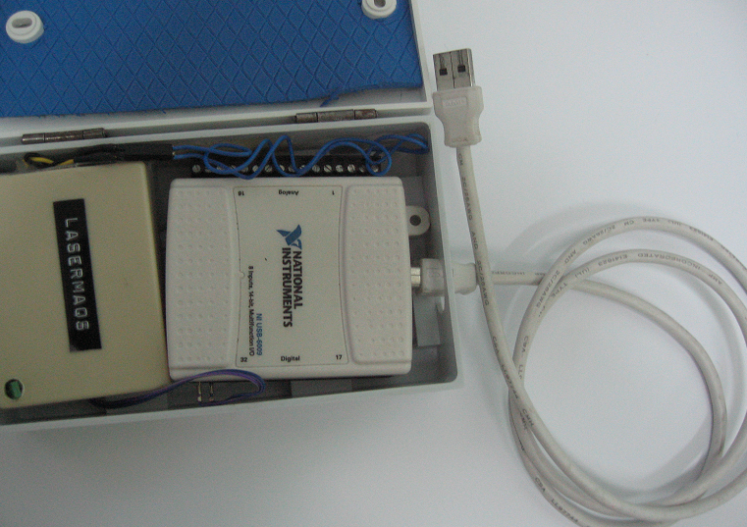

From Monash
- Clicker + transmitter
- Laser mount
- Laser

